**Example 1:**

**Code:**

clear

clc

syms w

n = 0:20;

x = 0.8.^n;

X = sum(x.*exp(-j*w*n));

ezplot(abs(X),[-pi pi])

title('Magnitude of DTFT')

ylim([0 5.4])

**Result:**

**Code:**

clear

clc

pkg load symbolic

syms w

n = 0:20;

x = 0.8.^n;

X=sum(x.*exp(-j*w*n));

ezplot(abs(X),[-5*pi 5*pi]);

title('Magnitude of DTFT in 5 periods')

ylim([0 5.8])

**Result:**

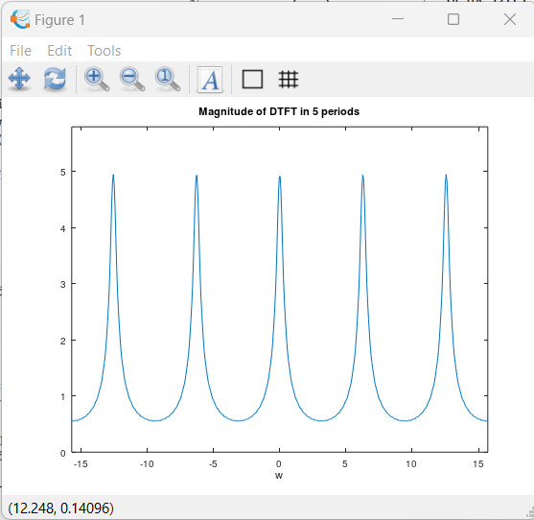

**Example 2:**

**Code:**

**Result:**